The certificate file is rclaw.p12 which is in the source directory

The certificate password is l2R019a1C5w

The instructions for importing the certificate are here:

<http://windows.microsoft.com/en-us/windows/import-export-certificates-private-keys#1TC=windows-7>

The certificate should be imported to Certificates (Local Compter)\Personal

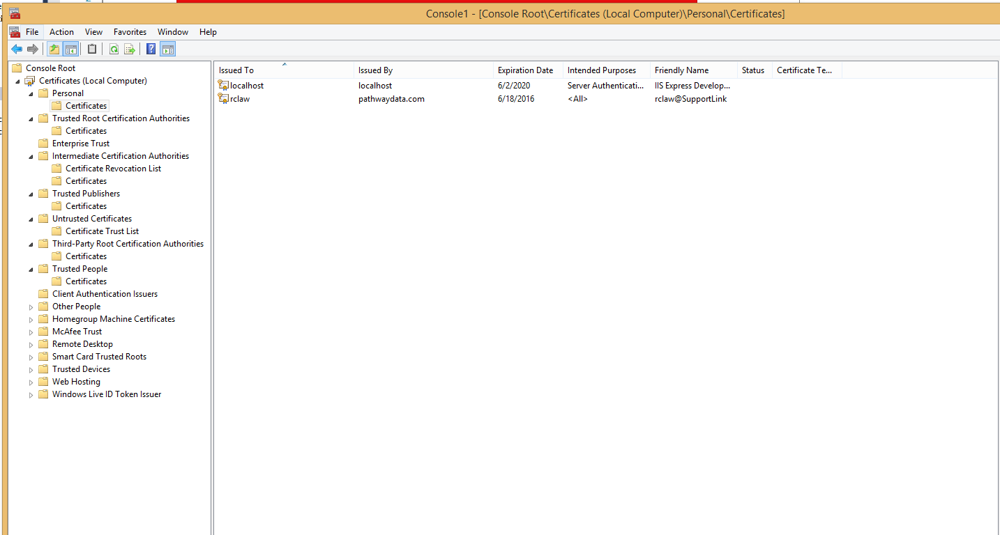

I had a problem that I could access the website using a brower, which sent the certificates, but the api returns “SSL certificates not sent”.

I’m not sure how I fixed it, but it seemed to work after I followed some instructions in Fiddler

<http://www.telerik.com/blogs/faq---certificates-in-fiddler>

I followed all the instructions, including installing CertMaker.